**Дата**: 21.11.2024

**Клас**: 9-Б

**Предмет**: англійська мова

**Тема:** Підсумковий урок з теми : «Засоби масової інформації».

**Мета:** : формувати навички вживання лексичних одиниць по темі; удосконалювати навички читання, аудіювання й усного монологічного мовлення; розвивати пізнавальні інтереси учнів; виховувати інтерес до самостійного пошуку потрібної інформації, а також загальну культуру учнів.

**Вчитель**: Руда Д.В.

Хід уроку

1.Greeting

Good afternoon, guys! I’m glad to see you. Are you ready to start our

lesson? All set?

2. Wаrm up / Listening

Уважно слухати аудіо трек і дати відповідь на питання вчителя <https://www.youtube.com/watch?v=bNuosP8ty1E> .

3. Speaking

How do you find out about what’s going on in the world?

Is it important to know what is happening in the world? Why?

Do you ever use social media sites like Twitter and Reddit? Are they a good idea?

When was the last time you bought a newspaper? Do they have a future?

How often do you watch the news on television? Which is the best channel for news?

Do you have a favourite newsreader or journalist? Why do you like them?

Do you ever read or watch news from other countries? Why do you do this?

Do you think the media reports news better than it did 25 years ago or worse?

What, in your opinion, is the most trustworthy source of news?

What, in your view, makes a good journalist?

Should newspapers be allowed to write anything they want?

Do you think the media has the power to influence people? How so?

On the whole, do you trust what journalists in your country say?

Do you think that ‘fake news’ has become a problem? What can we do about it?

Why is the media so interested in celebrities? Do you find celebrities interesting?

Is it right when the newspapers report on a politician’s private life?

Who would you say controls the media in your country?

What can be done to improve the quality of the media?

4. Повторення

Повторити граматику Past Perfect.

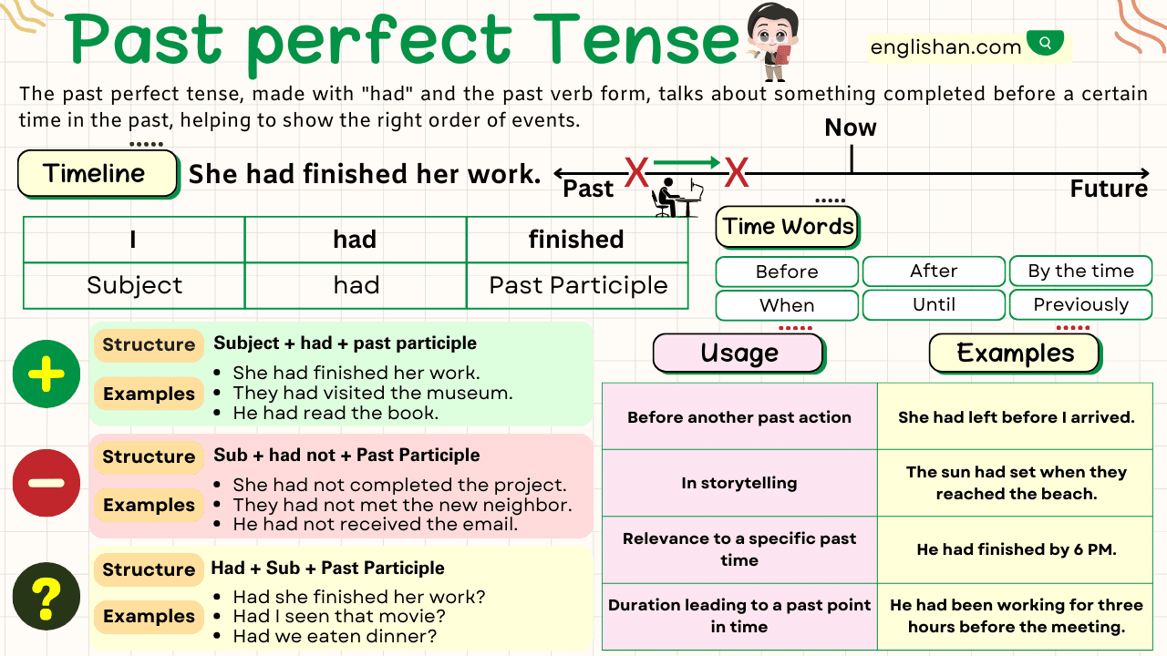

5. Writing

Виконати вправу продану нижче.

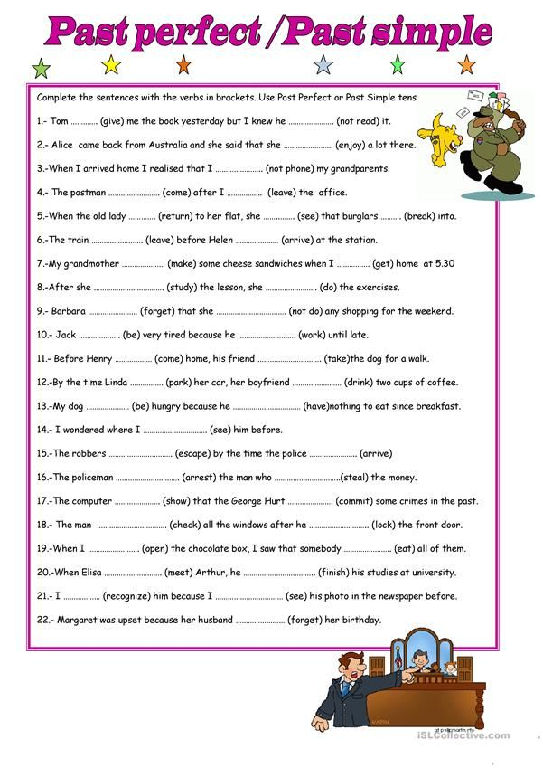

6. Homework

1. Обов’язково виконати контрольний тест на платформі [join.naurok.ua](http://join.naurok.ua/) .

Код доступу 4683047 .